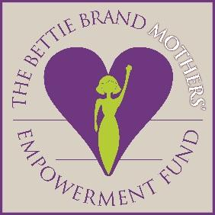 CANDIDATE APPLICATION: “SPIRIT AWARD”
The Bettie Brand Mothers’ Empowerment Fund (www.BettieBrand.org)

Directions: Please fill out Part A (Current Information) and Part B (Essay) as honestly and completely as possible and email them no later than Nov. 2, 2021 to: Pbullock@bettiebrand.org. Thank you.

PART A: CURRENT INFORMATION

Your Name:
Date of Application Submission:
Sponsor Organization:
Age AND Date of Birth:
Race:
Yearly Income level (Check one): Less than $10,000 ____________ $10,000-20,000_________ $20,500-40,000______
More than $40,000____________
Other financial support (if applicable, source and approximate amount):
Marital Status:
Number of Children (if applicable):
Ages of Children (if applicable):
Current Employment (if applicable):
Contact phone number (if applicable):
Email Address (if applicable):
Home Address (if applicable):

PART B: ESSAY
Each year the Bettie Brand Mothers’ Empowerment Fund awards grants (not to exceed $10,000 and to be used within 3 years) for a Georgia woman 17 years or older who needs a hand up (not a hand out) in order to help her live a life of independence with dignity. In addition, each recipient is asked to ‘pay it forward’ in whatever way she finds possible in the future (example: helping another woman in need). In 500 words or less, tell us 1) how a grant could change your life (please be as specific as possible) and 2) why you believe you are one of the best candidates for this year’s Bettie Brand Mothers’ Empowerment Fund Spirit Award.
Note: By submitting this application you are agreeing to have your name, picture, and story shared for inspirational and fundraising purposes on any platform by the Bettie Brand Mothers’ Empowerment Fund, if you are selected as a recipient.
If you are selected as a recipient, the grant may ONLY be used within the state of Georgia.

