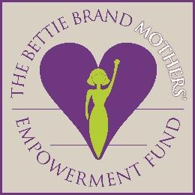 SPONSOR RECOMMENDATION: “SPIRIT AWARD”
The Bettie Brand Mothers’ Empowerment Fund (www.BettieBrand.org)

Directions: As a sponsor, while you may select two candidates, we ask that you kindly fill out the following information PER CANDIDATE as honestly and completely as possible and email it no later than Nov. 2, 2020 to: Pbullock@bettiebrand.org. Thank you.

Date: Organization:
Your Name: Position:
Contact Phone #:
Name and Relationship of Candidate:
Is the candidate a family member of yours? No_____ Yes__________
If “Yes,” how is she related to you?

Each year the Bettie Brand Mothers’ Empowerment Fund awards grants (not to exceed $10,000 and to be used within 3 years) for a Georgia woman 17 years or older who needs a hand up (not a hand out) in order to help her live a life of independence with dignity. In addition, each recipient is asked to ‘pay it forward’ in whatever way she finds possible in the future (example: volunteering to help another woman in need). In 500 words or less, please tell us, below, why you believe she is one of the best candidates for this year’s Bettie Brand Mothers’ Empowerment Fund Spirit Award. Thank you for your time and efforts.

